The American International Group (AIG) is one of the largest finance and insurance corporations in the world. The data in this dataset shows the stock price on a monthly average of AIG on the New York Stock Exchange over the course of five years, 2002 to 2007. It also has a column dedicated to the volume of the stock, which is how many people bought or sold the stock during that month. According to the dataset description, the price for the stock fell almost to $0 between 2007 and 2009. The data for that part of the stock price history is not included, but the question was whether or not this price drop could have been predicted with the data that was given.

In order to analyze this data I chose to use Excel pivot tables and pivot charts, as well as RStudio to easily find certain statistical metrics.

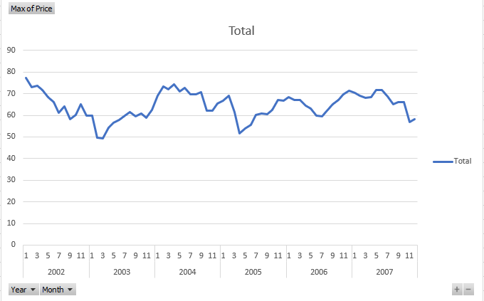

The above line graph depicts the price of AIG stock per month in a given year. As you can see, the price doesn’t fall much lower than $50 and doesn’t get much higher than $75 throughout the five years. Seems somewhat typical for how a stock performs. It had some significant drops, and some significant gains, but when it looks to drop much faster than it gains.

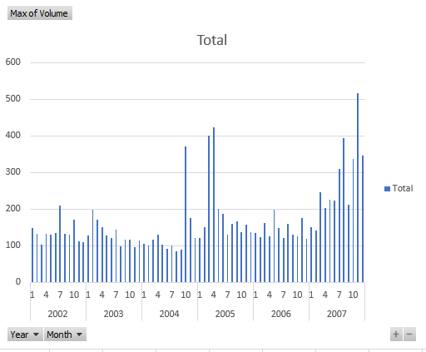

This bar graph depicts the volume of AIG stock per month in a given year. As you can see, there are pretty massive spikes in volume at the end of 2004 and beginning of 2005, as well as multiple large volume months towards the end of 2007. If you compare the volume spikes to the price graph above, you can infer that in October of 2004 people were trying to buy the dip, with the idea that the price would rise, which it did slightly. However, a few months later in April of 2005, there was a significant sell off, which can be seen on both graphs with the volume spike and the price drop. The next year and a half saw volume around average which I calculated in R at 170.07. The next major event was at the second half of 2007 when volume sored to its max of the five years, 515.62. Obviously, this is where the data stops, but you can see in the price graph that it was dipping significantly, and looked to possibly be heading back to where it was in the middle of 2005 which was around $53 to $55.





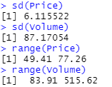

The standard deviation and range of the price shows that it didn’t change all that much from the average. The standard deviation and range of volume shows that it can jump very high and fall pretty low, which makes sense in terms of trading stocks.

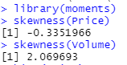

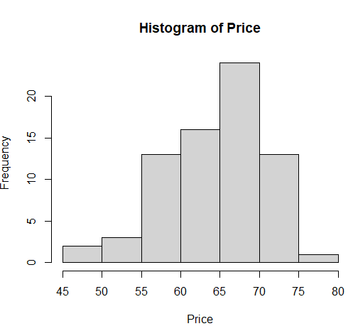

The histogram of the price shows where the price is most often valued, most commonly being between $65 and $70.

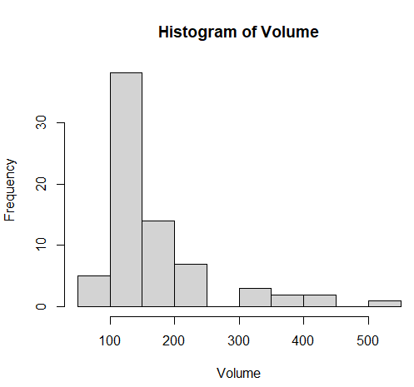

The histogram of volume shows what value volume was at most frequently. I did not think either of the histograms were that helpful other than sort of visualizing the average value of both price and volume.

To answer the question of whether the price drop in the following years could have been predicted, I would say no. The massive sell off towards the end of 2007 is definitely a red flag, both with the volume spike and the price dropping. I am also assuming this isn’t real data since AIG stock price was much higher in these years than what the data shows. But if this data could have predicted the stock price fall around 2008, people would have been able to predict the 2008 financial crisis since almost every stock, especially with financial institutions, fell significantly in those years.